

CAPSTONE PROJECT REPORT
Report 4 – Software Design Specification

– Hanoi, Aug 2026 –

Table of Contents
Change Log 4
I. High Level Design 5
1. Software Architecture 5
2. Package Diagram 8
3. Database Design 9
3.1 chains 10
3.2 locations 10
3.3 room_types 11
3.4 rooms 11
3.5 assets 11
3.6 users 12
3.7 refresh_tokens 12
3.8 staff_location_assignments 12
3.9 staff_employments 12
3.10 schedule_plans 13
3.11 shifts 13
3.12 operational_tasks 14
3.13 residents 14
3.14 contracts 15
3.15 contract_signings 15
3.16 security_deposits 16
3.17 contract_residents 16
3.18 room_inspections 16
3.19 temporary_residence_tasks 17
3.20 billing_policies 18
3.21 meters 18
II. Detailed Code Design 22
1. Location Setup and Configuration 22
1.1 Class Diagram 22
1.2 Create Location and Initial Configuration 23
1.3 Update / Remove Location Configuration 24
2. Main Tenancy Contract Creation and Activation 25
2.1 Class Diagram 25
2.2 Main Tenancy Contract Creation and Activation Sequence Diagram 25
3.Contract Termination and Move-out Settlement 26
3.1 Contract Termination and Move-out Settlement Sequence Diagram 26
4. Meter Reading, Billing and Payment Management 28
4.1 Class Diagram 28
4.2 Meter Reading and Invoice Cycle Sequence Diagram 30
4.3 Bank Payment, Debt and Invoice Adjustment Sequence Diagram 31
5. Incident and Maintenance Management 31
5.1 Class Diagram 31
5.2 Sequence Diagram 34
III. Design for Non-Functional Requirements 36
1. Security Design 37
1.1 Authentication Flow 37
1.2 Authorization & RBAC Implementation 38
1.3 Data Protection 38
2. Performance & Scalability Design 39
2.1 Caching Strategy 39
2.2 Database Query Optimization 40
2.3 Background Processing 40
3. Reliability & Recoverability Design 40
3.1 Integration Failure Handling 40
3.2 Data Consistency & Recovery 41
4. Privacy & Test Data Design 41
5. Usability Design 42

Change Log
Date | A*  M, D | In charge | Change Description
19/10/2026 | A | Nguyen Quoc Huy | Created the initial Report 4 structure and aligned the design with BHOME requirements.
22/10/2026 | A | Nguyen Quoc Huy | Added Software Architecture Diagram and component descriptions.
27/10/2026 | A | Bui Bao Long | Added two Sequence Diagrams for Main Tenancy Contract Creation and Activation, and Contract Termination and Move-out Settlement.
27/10/2026 | M | Dinh Thien Huy | Added the Database Design Diagram and completed Section 4: Meter Reading, Billing and Payment Management, including the Class Diagram and Sequence Diagrams.
27/10/2026 | M | Vu Xuan Truong | Updated the database design to align with recent architectural refinements, and added the Class Diagram and Sequence Diagram for the Location Setup and Configuration module.
29/10/2026 | M | Bui Bao Long | Updated the Package Diagram and package descriptions to reflect the system architecture and dependencies between packages.
29/10/2026 | M | Nguyen Quoc Huy | Updated the Software Architecture, Package Diagram and package descriptions to match the BHOME system structure.
*A - Added M - Modified D - Deleted

I. High Level Design

1. Software Architecture
BHOME uses a layered architecture with two client applications communicating with a centralized ASP.NET Core 8 Web API through HTTPS/REST/JSON.
The BHOME Web Application, built with React, TypeScript, and Vite, combines Owner Management and Public Information into a single web application. Owner Management provides authenticated access to configuration, staff, contracts, billing, finance, reporting, and business analysis, while Public Information allows Guests to view approved Location and Room information. The BHOME Mobile Application, built with React, TypeScript, and Capacitor, supports Owner monitoring and quick actions, Staff daily operations, and Tenant self-service.
The backend uses ASP.NET Core Identity, JWT, and Role-Based Access Control (RBAC) for authentication and authorization, including Location-based access restrictions. The HTTP Middleware and API Pipeline handle HTTPS requests, CORS, exception handling, logging, and security checks. The Controller Layer exposes REST API endpoints, validates requests using DTOs, and delegates processing to the Service Layer, which implements BHOME's core business logic. Internal OCR assists meter and CCCD data capture, while Background Jobs handle invoice generation, reminders, retries, and recurring operational tasks.
Structured business data is stored in PostgreSQL through the Data Access Layer, using repositories and Entity Framework Core 8 for persistence and transactions. Images, contract documents, and evidence files are managed through a File Storage Adapter and stored in MinIO/S3-compatible Object Storage.
BHOME also integrates with external services for bank payment reconciliation, push/email notifications, and electronic contract signing.
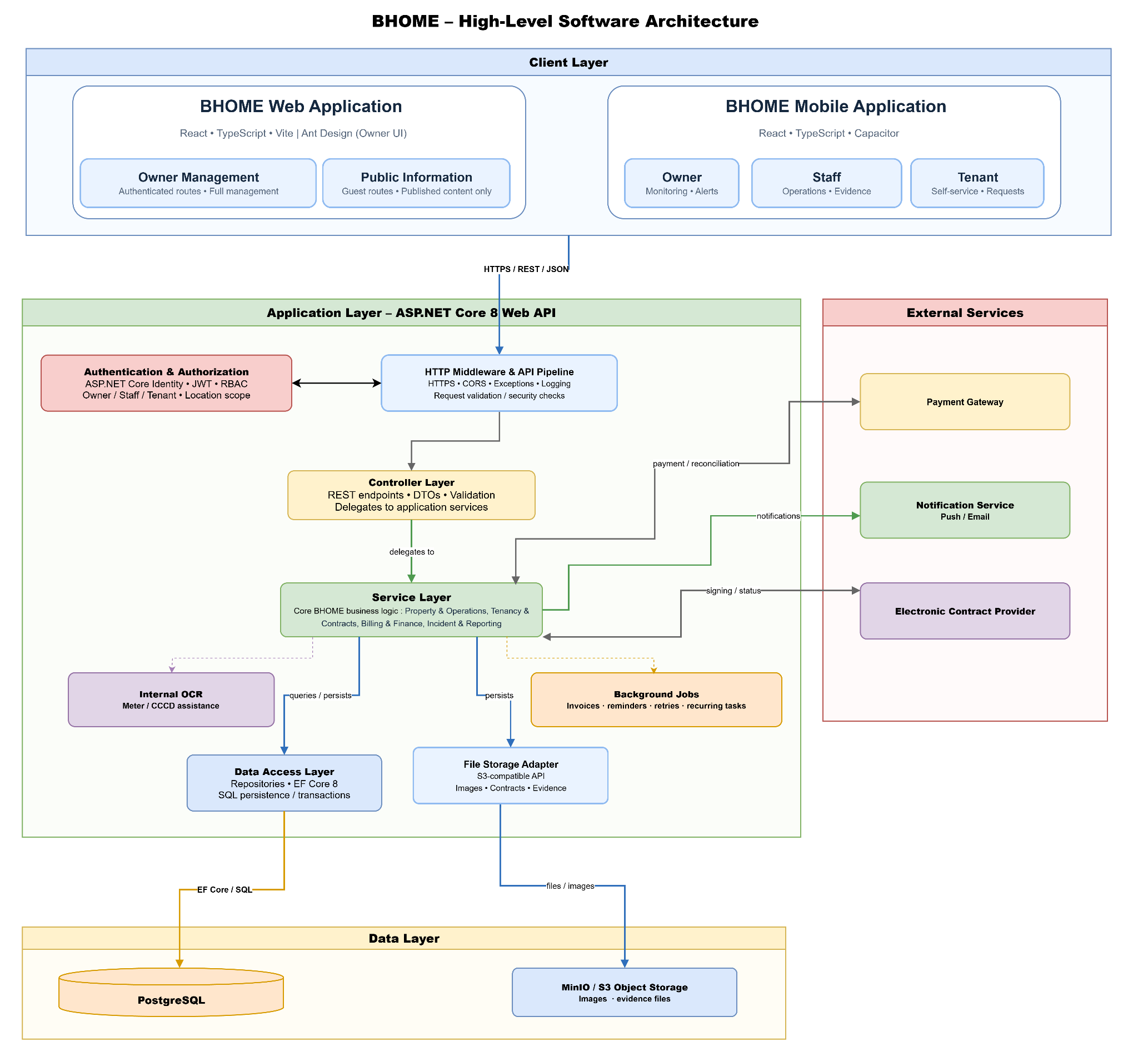
Architecture component descriptions
No | Component | Description
Client Layer
1 | BHOME Web Application | React-based web application providing authenticated Owner Management and public Location and Room information for Guests.
2 | BHOME Mobile Application | React and Capacitor-based mobile application supporting Owner monitoring and alerts, Staff operations, and Tenant self-service.
Application Layer
1 | Authentication & Authorization | Uses ASP.NET Core Identity, JWT, and RBAC to authenticate users and enforce role-based and Location-based access permissions.
2 | HTTP Middleware & API Pipeline | Processes HTTPS requests and handles CORS, exception handling, logging, request validation, and security checks.
3 | Controller Layer | Exposes REST API endpoints, processes DTOs, validates requests, and delegates business operations to application services.
4 | Service Layer | Implements core business logic for property operations, tenancy, contracts, billing, finance, incident management, and reporting.
5 | Internal OCR | Extracts proposed meter readings and CCCD information from images for user verification before official use.
6 | Background Jobs | Executes automated tasks such as invoice generation, reminders, retries, and recurring operational task generation.
7 | Data Access Layer | Uses repositories and Entity Framework Core 8 to manage database queries, persistence, and transactions.
8 | File Storage Adapter | Manages images, contracts, and evidence files through an S3-compatible storage interface.
Data Layer
1 | PostgreSQL | Stores structured BHOME business data such as users, rooms, contracts, invoices, payments, and operational records.
2 | MinIO / S3 Object Storage | Stores files such as meter images, contract documents, and incident or maintenance evidence.
External Services
1 | Payment Gateway | Provides bank-transfer transaction data for automatic or manual payment reconciliation.
2 | Notification Service | Delivers supported push notifications and emails to BHOME users.
3 | Electronic Contract Provider | Supports electronic contract signing and returns signing status and evidence to BHOME.

2. Package Diagram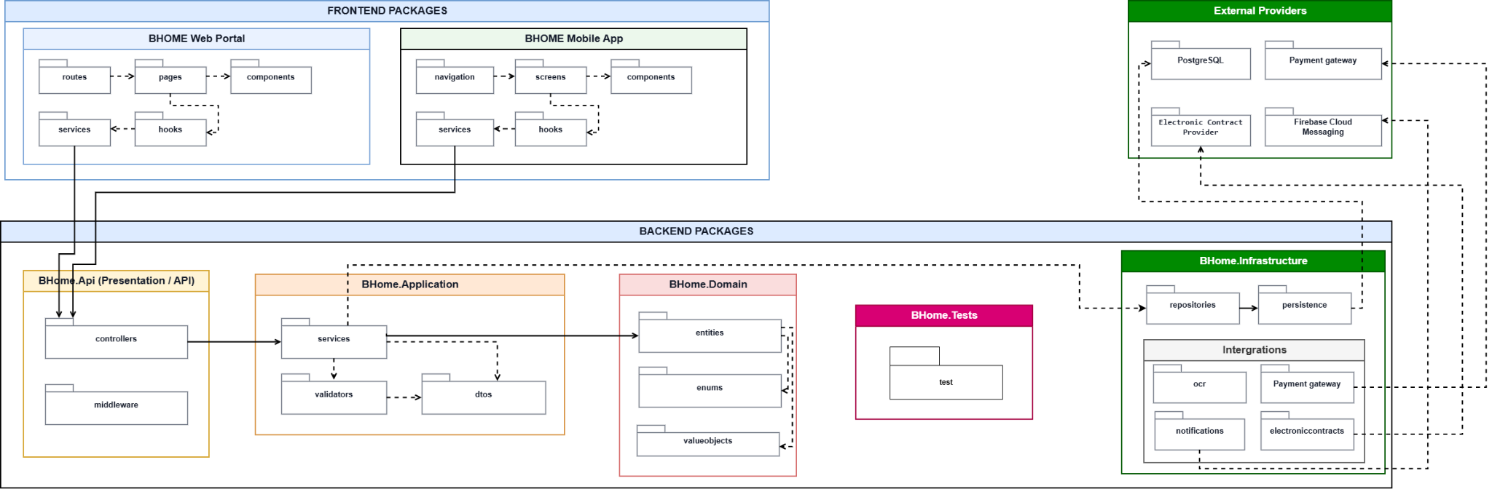
Package descriptions

No | Package | Description
1 | routes | Defines navigation routes for the Owner Web Portal and maps URLs to corresponding pages.
2 | pages | Contains page-level components of the Owner Web Portal, such as dashboard, contract management, room management, and financial management pages.
3 | components | Contains reusable UI components shared across Owner Web Portal pages.
4 | services | Handles API communication between the Owner Web Portal and the BHOME backend.
5 | navigation | Defines the navigation structure and screen transitions of the BHOME Mobile Application.
6 | screens | Contains application screens used by Owner, Staff, and Tenant.
7 | components | Contains reusable UI components shared between Mobile Application screens.
8 | services | Handles REST API communication between the Mobile Application and the BHOME backend.
9 | controllers | Exposes REST API endpoints and handles incoming HTTP requests from frontend applications.
10 | middleware | Handles cross-cutting HTTP processing such as authentication, authorization, exception handling, and request processing.
11 | services | Implements application-level business workflows and coordinates Domain and Infrastructure components.
12 | dtos | Contains Data Transfer Objects used to transfer request and response data between layers.
13 | validators | Contains validation rules for application requests before business processing.
14 | entities | Contains the core BHOME business entities, such as Contract, Room, Tenant, Invoice, and Payment.
15 | enums, valueobjects | Defines abstractions used by the Application and Domain layers.
16 | persistence | Handles database access, repository implementations, and persistence configuration.
17 | storage | Handles file, image, document, and evidence storage.
18 | ocr | Handles internal OCR processing for assisted data capture, especially electricity and water meter readings.
19 | Payment gateway | Handles bank transaction integration and payment reconciliation.
20 | notifications | Handles push notification and email delivery.
21 | electronic contracts | Handles integration with the external Electronic Contract Provider, including contract submission and signing-status retrieval.
22 | tests | Contains automated tests to verify system functionality and correctness.

3. Database Design

BHOME stores all business data in a single PostgreSQL 16 database accessed through Entity Framework Core. The physical design has 39 tables in 6 modules, linked by 99 foreign keys; files such as contracts, meter photos and incident evidence are stored in MinIO, and the database keeps only their object keys.
The design follows the business flows in Report 3: a chain owns Locations, Locations own Room Types and Rooms, a Room is rented through Contracts, Contracts drive meter readings, Invoices and Payments, and Rooms and Assets are the subject of incidents, maintenance and operating costs.
Figure 3.1 shows the Overall ERD; Figures 3.2–3.7 show one ERD per module with the related tables of other modules for context. The diagrams use crow's foot notation: the crow's foot is on the table that holds the foreign key (many sides) and the bar is on the referenced table (one side); a dashed loop marks a self-reference.
To keep the Overall ERD readable, 27 relationships to users that only record who created, assigned, verified or decided a record (for example created_by_user_id, verified_by_user_id) are not drawn; each remains a foreign key column in its table and is shown in the module ERDs.
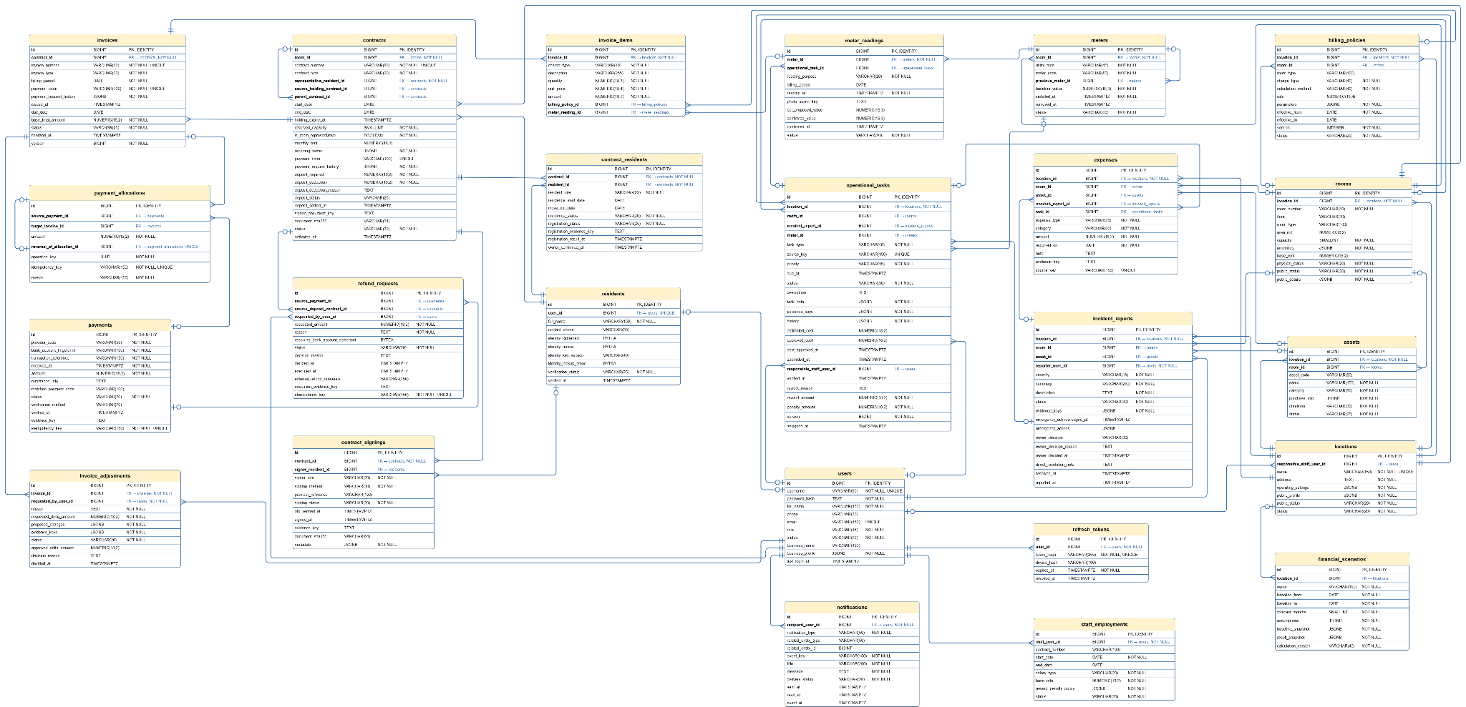

3.1 chains
Column | Type | Constraints | Notes
id | BIGSERIAL | PRIMARY KEY | Auto-increment
name | VARCHAR(150) | NOT NULL
business_settings | JSONB | NOT NULL DEFAULT '{}' | Chain-wide settings (billing day, reminders, defaults)
public_profile | JSONB | NOT NULL DEFAULT '{}' | Business name, logo and contact shown on the Public Website
status | VARCHAR(20) | NOT NULL | Lifecycle status; allowed values and transitions checked in the Service layer
created_at | TIMESTAMPTZ | NOT NULL DEFAULT NOW() | Set when the record is created

3.2 locations
Column | Type | Constraints | Notes
id | BIGSERIAL | PRIMARY KEY | Auto-increment
chain_id | BIGINT | FK, NOT NULL | → chains.id
name | VARCHAR(150) | NOT NULL
address | TEXT | NOT NULL | Full address of the building
public_status | VARCHAR(20) | NOT NULL DEFAULT 'HIDDEN' | HIDDEN until the Owner publishes the Location
status | VARCHAR(20) | NOT NULL | Lifecycle status; allowed values and transitions checked in the Service layer
created_at | TIMESTAMPTZ | NOT NULL DEFAULT NOW() | Set when the record is created

3.3 room_types
Column | Type | Constraints | Notes
id | BIGSERIAL | PRIMARY KEY | Auto-increment
location_id | BIGINT | FK, NOT NULL | → locations.id
name | VARCHAR(100) | NOT NULL
description | TEXT
default_capacity | SMALLINT | NOT NULL DEFAULT 1 | Default number of occupants for rooms of this type
area_m2 | NUMERIC(8,2)
amenities | JSONB | NOT NULL DEFAULT '[]' | List of amenities (air-con, balcony…)
status | VARCHAR(20) | NOT NULL | Lifecycle status; allowed values and transitions checked in the Service layer
created_at | TIMESTAMPTZ | NOT NULL DEFAULT NOW() | Set when the record is created
updated_at | TIMESTAMPTZ | NOT NULL DEFAULT NOW() | Updated on every change

3.4 rooms
Column | Type | Constraints | Notes
id | BIGSERIAL | PRIMARY KEY | Auto-increment
location_id | BIGINT | FK, NOT NULL | → locations.id
room_type_id | BIGINT | FK | → room_types.id; optional, a room may have no type
room_number | VARCHAR(50) | NOT NULL | Unique within the Location
floor | VARCHAR(30)

3.5 assets
Column | Type | Constraints | Notes
id | BIGSERIAL | PRIMARY KEY | Auto-increment
location_id | BIGINT | FK, NOT NULL | → locations.id
room_id | BIGINT | FK | → rooms.id; empty for shared assets of the Location
asset_code | VARCHAR(80)
name | VARCHAR(150) | NOT NULL
category | VARCHAR(80) | NOT NULL
purchase_info | JSONB | NOT NULL DEFAULT '{}' | Supplier, price, purchase date, warranty
condition | VARCHAR(30) | NOT NULL | Current condition; updated by inspections and maintenance
status | VARCHAR(25) | NOT NULL | In use, needs repair, under repair, retired
created_at | TIMESTAMPTZ | NOT NULL DEFAULT NOW() | Set when the record is created
updated_at | TIMESTAMPTZ | NOT NULL DEFAULT NOW() | Updated on every change

3.6 users
Column | Type | Constraints | Notes
id | BIGSERIAL | PRIMARY KEY | Auto-increment
chain_id | BIGINT | FK, NOT NULL | → chains.id
username | VARCHAR(50) | NOT NULL, UNIQUE | Login identifier
password_hash | VARCHAR(255) | NOT NULL | Hash produced by ASP.NET Core Identity; never plaintext
full_name | VARCHAR(150) | NOT NULL
email | VARCHAR(150) | UNIQUE | Optional; unique when present
phone | VARCHAR(30)
role | VARCHAR(20) | NOT NULL | OWNER, STAFF or TENANT
account_status | VARCHAR(25) | NOT NULL | Active, locked or deactivated; non-active accounts cannot sign in
last_login_at | TIMESTAMPTZ |  | Time of the last successful sign-in
created_at | TIMESTAMPTZ | NOT NULL DEFAULT NOW() | Set when the record is created
updated_at | TIMESTAMPTZ | NOT NULL DEFAULT NOW() | Updated on every change

3.7 refresh_tokens
Column | Type | Constraints | Notes
id | BIGSERIAL | PRIMARY KEY | Auto-increment
user_id | BIGINT | FK, NOT NULL | → users.id
token_hash | VARCHAR(255) | NOT NULL, UNIQUE | Hash of the refresh token; the raw token is only on the device
expires_at | TIMESTAMPTZ | NOT NULL
revoked_at | TIMESTAMPTZ |  | Set on logout, password change or account deactivation
created_at | TIMESTAMPTZ | NOT NULL DEFAULT NOW() | Set when the record is created

3.8 staff_location_assignments
Column | Type | Constraints | Notes
id | BIGSERIAL | PRIMARY KEY | Auto-increment
staff_user_id | BIGINT | FK, NOT NULL | → users.id (Staff)
location_id | BIGINT | FK, NOT NULL | → locations.id
effective_from | DATE | NOT NULL
effective_to | DATE |  | Empty while the assignment is open-ended
status | VARCHAR(20) | NOT NULL | Lifecycle status; allowed values and transitions checked in the Service layer
created_at | TIMESTAMPTZ | NOT NULL DEFAULT NOW() | Set when the record is created
updated_at | TIMESTAMPTZ | NOT NULL DEFAULT NOW() | Updated on every change

3.9 staff_employments
Column | Type | Constraints | Notes
id | BIGSERIAL | PRIMARY KEY | Auto-increment
staff_user_id | BIGINT | FK, NOT NULL | → users.id
contract_number | VARCHAR(100)
employment_type | VARCHAR(40)
start_date | DATE | NOT NULL
end_date | DATE
salary_type | VARCHAR(30) | NOT NULL | Monthly, hourly or per-shift
salary_rate | NUMERIC(18,2) | NOT NULL | Amount in VND per salary unit
status | VARCHAR(20) | NOT NULL | Lifecycle status; allowed values and transitions checked in the Service layer
created_at | TIMESTAMPTZ | NOT NULL DEFAULT NOW() | Set when the record is created
updated_at | TIMESTAMPTZ | NOT NULL DEFAULT NOW() | Updated on every change

3.10 schedule_plans
Column | Type | Constraints | Notes
id | BIGSERIAL | PRIMARY KEY | Auto-increment
location_id | BIGINT | FK, NOT NULL | → locations.id
period_start | DATE | NOT NULL
period_end | DATE | NOT NULL
version | INTEGER | NOT NULL DEFAULT 1 | Incremented on each re-confirmed change
status | VARCHAR(20) | NOT NULL | Lifecycle status; allowed values and transitions checked in the Service layer
confirmed_by_user_id | BIGINT | FK | → users.id (Owner who confirmed the schedule)
confirmed_at | TIMESTAMPTZ
change_reason | TEXT |  | Required when a confirmed schedule is changed
created_at | TIMESTAMPTZ | NOT NULL DEFAULT NOW() | Set when the record is created
updated_at | TIMESTAMPTZ | NOT NULL DEFAULT NOW() | Updated on every change

3.11 shifts
Column | Type | Constraints | Notes
id | BIGSERIAL | PRIMARY KEY | Auto-increment
schedule_plan_id | BIGINT | FK, NOT NULL | → schedule_plans.id
location_id | BIGINT | FK, NOT NULL | → locations.id
staff_user_id | BIGINT | FK, NOT NULL | → users.id
planned_start | TIMESTAMPTZ | NOT NULL
planned_end | TIMESTAMPTZ | NOT NULL
actual_start | TIMESTAMPTZ |  | Recorded at check-in
actual_end | TIMESTAMPTZ |  | Recorded at check-out
source | VARCHAR(30) | NOT NULL DEFAULT 'OWNER' | OWNER when planned by the Owner; other values for swaps
change_reason | TEXT
status | VARCHAR(20) | NOT NULL | Lifecycle status; allowed values and transitions checked in the Service layer
created_at | TIMESTAMPTZ | NOT NULL DEFAULT NOW() | Set when the record is created
updated_at | TIMESTAMPTZ | NOT NULL DEFAULT NOW() | Updated on every change

3.12 operational_tasks
Column | Type | Constraints | Notes
id | BIGSERIAL | PRIMARY KEY | Auto-increment
location_id | BIGINT | FK, NOT NULL | → locations.id
room_id | BIGINT | FK | → rooms.id
assigned_staff_user_id | BIGINT | FK | → users.id
task_type | VARCHAR(50) | NOT NULL | Meter reading, inspection, handover, cleaning, maintenance…
priority | VARCHAR(20) | NOT NULL DEFAULT 'NORMAL' | NORMAL by default; URGENT for emergencies
source | VARCHAR(30) | NOT NULL | Who or what created the task (Owner, schedule, system job)
assigned_at | TIMESTAMPTZ
due_at | TIMESTAMPTZ
progress_note | TEXT
evidence | JSONB | NOT NULL DEFAULT '[]' | MinIO object keys of photos
status | VARCHAR(30) | NOT NULL | Lifecycle status; allowed values and transitions checked in the Service layer
verified_by_user_id | BIGINT | FK | → users.id (Owner who verified the result)
verified_at | TIMESTAMPTZ
created_at | TIMESTAMPTZ | NOT NULL DEFAULT NOW() | Set when the record is created
updated_at | TIMESTAMPTZ | NOT NULL DEFAULT NOW() | Updated on every change

3.13 residents
Column | Type | Constraints | Notes
id | BIGSERIAL | PRIMARY KEY | Auto-increment
user_id | BIGINT | FK | → users.id; empty until the resident has an app account
full_name | VARCHAR(150) | NOT NULL
phone | VARCHAR(30)
email | VARCHAR(150)
identity_data | JSONB | NOT NULL DEFAULT '{}' | CCCD fields confirmed by Staff; CCCD images are not kept
verification_status | VARCHAR(30) | NOT NULL | Identity verification state (pending, verified, rejected)
status | VARCHAR(20) | NOT NULL | Lifecycle status; allowed values and transitions checked in the Service layer
created_at | TIMESTAMPTZ | NOT NULL DEFAULT NOW() | Set when the record is created
updated_at | TIMESTAMPTZ | NOT NULL DEFAULT NOW() | Updated on every change

3.14 contracts
Column | Type | Constraints | Notes
id | BIGSERIAL | PRIMARY KEY | Auto-increment
contract_number | VARCHAR(80) | NOT NULL, UNIQUE | Business code shown on documents
contract_type | VARCHAR(30) | NOT NULL | HOLDING or MAIN
room_id | BIGINT | FK, NOT NULL | → rooms.id
primary_tenant_resident_id | BIGINT | FK, NOT NULL | → residents.id (main tenant who signs)
source_holding_contract_id | BIGINT | FK | → contracts.id; holding Contract converted into this main Contract
parent_contract_id | BIGINT | FK | → contracts.id; previous Contract when this one is a renewal
start_date | DATE
end_date | DATE
holding_expiry_at | TIMESTAMPTZ |  | Holding Contract expires if no main Contract is signed by this time
monthly_rent | NUMERIC(18,2) |  | Agreed rent in VND
recurring_terms | JSONB | NOT NULL DEFAULT '{}' | Billing day, included services and other recurring terms
status | VARCHAR(30) | NOT NULL | Draft, pending signing, active, expired, terminated…
created_at | TIMESTAMPTZ | NOT NULL DEFAULT NOW() | Set when the record is created
updated_at | TIMESTAMPTZ | NOT NULL DEFAULT NOW() | Updated on every change

3.15 contract_signings
Column | Type | Constraints | Notes
id | BIGSERIAL | PRIMARY KEY | Auto-increment
contract_id | BIGINT | FK, NOT NULL | → contracts.id
signer_user_id | BIGINT | FK, NOT NULL | → users.id
signer_role | VARCHAR(20) | NOT NULL | OWNER or TENANT
provider_reference | VARCHAR(150) |  | Session or document ID at the e-contract provider
signing_status | VARCHAR(20) | NOT NULL | Pending, signed, rejected or expired at the provider
signed_at | TIMESTAMPTZ
evidence_reference | TEXT |  | Signed-document reference returned by the provider
created_at | TIMESTAMPTZ | NOT NULL DEFAULT NOW() | Set when the record is created
updated_at | TIMESTAMPTZ | NOT NULL DEFAULT NOW() | Updated on every change

3.16 security_deposits

Column | Type | Constraints | Notes
id | BIGSERIAL | PRIMARY KEY | Auto-increment
contract_id | BIGINT | FK, NOT NULL, UNIQUE | → contracts.id; one deposit per Contract
required_amount | NUMERIC(18,2) | NOT NULL
applied_holding_amount | NUMERIC(18,2) | NOT NULL DEFAULT 0 | Holding money moved into the deposit
verified_bank_amount | NUMERIC(18,2) | NOT NULL DEFAULT 0 | Amount confirmed against the bank transaction
verified_by_user_id | BIGINT | FK | → users.id
verified_at | TIMESTAMPTZ
deduction_amount | NUMERIC(18,2) | NOT NULL DEFAULT 0 | Deducted at move-out for damage or debt
deduction_reason | TEXT
refundable_amount | NUMERIC(18,2) | NOT NULL DEFAULT 0 | Amount returned to the tenant at settlement
settled_by_user_id | BIGINT | FK | → users.id (Owner who settled the deposit)
settled_at | TIMESTAMPTZ
status | VARCHAR(20) | NOT NULL | Lifecycle status; allowed values and transitions checked in the Service layer
created_at | TIMESTAMPTZ | NOT NULL DEFAULT NOW() | Set when the record is created
updated_at | TIMESTAMPTZ | NOT NULL DEFAULT NOW() | Updated on every change

3.17 contract_residents

Column | Type | Constraints | Notes
id | BIGSERIAL | PRIMARY KEY | Auto-increment
contract_id | BIGINT | FK, NOT NULL | → contracts.id
resident_id | BIGINT | FK, NOT NULL | → residents.id
resident_role | VARCHAR(30) | NOT NULL | PRIMARY_TENANT or OCCUPANT
residence_start_date | DATE
move_out_date | DATE |  | Set when the occupant leaves
status | VARCHAR(20) | NOT NULL | Lifecycle status; allowed values and transitions checked in the Service layer
created_at | TIMESTAMPTZ | NOT NULL DEFAULT NOW() | Set when the record is created
updated_at | TIMESTAMPTZ | NOT NULL DEFAULT NOW() | Updated on every change

3.18 room_inspections
 | Column | Type | Constraints | Notes
id | BIGSERIAL | PRIMARY KEY | Auto-increment | id
contract_id | BIGINT | FK, NOT NULL | → contracts.id | contract_id
room_id | BIGINT | FK, NOT NULL | → rooms.id | room_id
inspection_type | VARCHAR(20) | NOT NULL | MOVE_IN or MOVE_OUT | inspection_type
inspection_at | TIMESTAMPTZ | NOT NULL |  | inspection_at
condition_summary | TEXT |  |  | condition_summary
asset_conditions | JSONB | NOT NULL DEFAULT '[]' | Condition of each asset at the inspection | asset_conditions
evidence | JSONB | NOT NULL DEFAULT '[]' | MinIO object keys of inspection photos | evidence
staff_user_id | BIGINT | FK | → users.id | staff_user_id
tenant_user_id | BIGINT | FK | → users.id (tenant who confirms the result) | tenant_user_id
status | VARCHAR(30) | NOT NULL | Lifecycle status; allowed values and transitions checked in the Service layer | status
created_at | TIMESTAMPTZ | NOT NULL DEFAULT NOW() | Set when the record is created | created_at
updated_at | TIMESTAMPTZ | NOT NULL DEFAULT NOW() | Updated on every change | updated_at

3.19 temporary_residence_tasks
Column | Type | Constraints | Notes
id | BIGSERIAL | PRIMARY KEY | Auto-increment
contract_resident_id | BIGINT | FK, NOT NULL | → contract_residents.id
actual_residence_start_date | DATE | NOT NULL
deadline | DATE |  | Legal deadline for temporary-residence registration
registration_status | VARCHAR(30) | NOT NULL
result_status | VARCHAR(30)
evidence | JSONB | NOT NULL DEFAULT '[]' | MinIO object keys of the registration proof
completed_at | TIMESTAMPTZ
confirmed_by_owner_user_id | BIGINT | FK | → users.id (Owner who confirms completion)
confirmed_at | TIMESTAMPTZ
created_at | TIMESTAMPTZ | NOT NULL DEFAULT NOW() | Set when the record is created
updated_at | TIMESTAMPTZ | NOT NULL DEFAULT NOW() | Updated on every change

3.20 billing_policies
Column | Type | Constraints | Notes
id | BIGSERIAL | PRIMARY KEY | Auto-increment
location_id | BIGINT | FK, NOT NULL | → locations.id
room_type_id | BIGINT | FK | → room_types.id; empty = applies to the whole Location
charge_category | VARCHAR(40) | NOT NULL | Rent, electricity, water, internet, service…
charging_method | VARCHAR(40) | NOT NULL | Per unit, fixed per room, per person or tiered
rate | NUMERIC(18,4) |  | Unit price in VND
parameters | JSONB | NOT NULL DEFAULT '{}' | Extra settings such as tiers or free quota
effective_from | DATE | NOT NULL
effective_to | DATE
version | INTEGER | NOT NULL DEFAULT 1 | New version on each change; old Invoices keep their snapshot
status | VARCHAR(20) | NOT NULL | Lifecycle status; allowed values and transitions checked in the Service layer
updated_by_user_id | BIGINT | FK | → users.id
created_at | TIMESTAMPTZ | NOT NULL DEFAULT NOW() | Set when the record is created
updated_at | TIMESTAMPTZ | NOT NULL DEFAULT NOW() | Updated on every change

3.21 meters

Column | Type | Constraints | Notes
id | BIGSERIAL | PRIMARY KEY | Auto-increment
room_id | BIGINT | FK, NOT NULL | → rooms.id
meter_code | VARCHAR(80) | NOT NULL
utility_type | VARCHAR(20) | NOT NULL | ELECTRICITY or WATER
baseline_value | NUMERIC(18,3) | NOT NULL DEFAULT 0 | Reading when the meter is installed
installed_at | TIMESTAMPTZ | NOT NULL
removed_at | TIMESTAMPTZ |  | Set when the meter is replaced
status | VARCHAR(20) | NOT NULL | Lifecycle status; allowed values and transitions checked in the Service layer
created_at | TIMESTAMPTZ | NOT NULL DEFAULT NOW() | Set when the record is created
updated_at | TIMESTAMPTZ | NOT NULL DEFAULT NOW() | Updated on every change

3.23 payment_allocations
Column | Type | Constraints | Notes
id | BIGINT | PRIMARY KEY, IDENTITY | Auto-increment surrogate key
source_payment_id | BIGINT | FK → payments(id) | Money source: a payment …
source_credit_id | BIGINT | FK → excess_balances(id) | … or an excess balance …
source_deposit_contract_id | BIGINT | FK → contracts(id) | … or a contract deposit; exactly one source is set
target_invoice_id | BIGINT | FK → invoices(id) | Target: an invoice …
target_deposit_contract_id | BIGINT | FK → contracts(id) | … or a contract deposit; exactly one target is set
amount | NUMERIC(18,2) | NOT NULL | Allocated amount (> 0)
reversal_of_allocation_id | BIGINT | FK → payment_allocations(id) | Set when this row reverses an earlier allocation
operation_key | UUID | NOT NULL | Groups the rows written by one business operation
idempotency_key | VARCHAR(150) | NOT NULL, UNIQUE | Prevents the same allocation from being written twice
reason | VARCHAR(150) | NOT NULL | e.g. "AUTO_MATCH", "MANUAL", "DEPOSIT_OFFSET"
created_by_user_id | BIGINT | FK → users(id) | NULL when created by the system
created_at | TIMESTAMPTZ | NOT NULL, DEFAULT NOW() | Set when the row is inserted (UTC)

3.24 excess_balances

Column | Type | Constraints | Notes
id | BIGINT | PRIMARY KEY, IDENTITY | Auto-increment surrogate key
owner_resident_id | BIGINT | NOT NULL, FK → residents(id) | Resident who owns the credit
room_stay_group_id | UUID |  | Stay group the credit belongs to
source_payment_id | BIGINT | NOT NULL, FK → payments(id) | Payment that created the over-payment
caused_by_adjustment_id | BIGINT | FK → invoice_adjustments(id) | Approved adjustment that turned paid money into credit
original_amount | NUMERIC(18,2) | NOT NULL | Credit amount when created; the remaining balance is derived from allocations
creation_key | VARCHAR(150) | NOT NULL, UNIQUE | Prevents duplicate credit for the same event
status | VARCHAR(20) | NOT NULL | OPEN / USED / REFUNDED
created_at | TIMESTAMPTZ | NOT NULL, DEFAULT NOW() | Set when the row is inserted (UTC)
updated_at | TIMESTAMPTZ | NOT NULL, DEFAULT NOW() | Refreshed on every update (UTC)

3.25 refund_requests
Column | Type | Constraints | Notes
id | BIGINT | PRIMARY KEY, IDENTITY | Auto-increment surrogate key
source_excess_balance_id | BIGINT | FK → excess_balances(id) | Credit to refund …
source_deposit_contract_id | BIGINT | FK → contracts(id) | … or deposit to refund; exactly one source is set
requested_by_user_id | BIGINT | NOT NULL, FK → users(id) | Tenant or Owner who created the request
beneficiary_resident_id | BIGINT | NOT NULL, FK → residents(id) | Resident who receives the money
requested_amount | NUMERIC(18,2) | NOT NULL | Amount to refund (> 0)
reason | TEXT | NOT NULL | Why the refund is needed
receiving_bank_account_ciphertext | BYTEA |  | Encrypted bank account of the beneficiary
status | VARCHAR(25) | NOT NULL | PENDING / APPROVED / REJECTED / EXECUTED
decided_by_owner_user_id | BIGINT | FK → users(id) | Owner who decided
decision_reason | TEXT |  | Required when rejected
decided_at | TIMESTAMPTZ |  | Decision time
executed_at | TIMESTAMPTZ |  | When the money was transferred
external_refund_reference | VARCHAR(150) |  | Bank transaction id of the refund
execution_evidence_key | TEXT |  | Private object-storage key of the transfer receipt
idempotency_key | VARCHAR(150) | NOT NULL, UNIQUE | Prevents duplicate requests
created_at | TIMESTAMPTZ | NOT NULL, DEFAULT NOW() | Set when the row is inserted (UTC)
updated_at | TIMESTAMPTZ | NOT NULL, DEFAULT NOW() | Refreshed on every update (UTC)

3.26 incident_reports

Column | Type | Constraints | Notes
id | BIGINT | PRIMARY KEY, IDENTITY | Auto-increment surrogate key
reporter_user_id | BIGINT | NOT NULL, FK → users(id) | Tenant or Staff who reported
location_id | BIGINT | NOT NULL, FK → locations(id) | Resolved from the room/asset on the server, not trusted from the client
room_id | BIGINT | FK → rooms(id) | NULL = common area
asset_id | BIGINT | FK → assets(id) | Asset involved, if any
severity | VARCHAR(30) | NOT NULL | NORMAL / OPERATIONAL_EMERGENCY (GBR-11)
status | VARCHAR(30) | NOT NULL | SUBMITTED / IN_PROGRESS / RESOLVED / REJECTED / DUPLICATE / CANCELLED
summary | VARCHAR(250) | NOT NULL | Short title shown in lists
report_description | TEXT | NOT NULL | At least 10 characters
evidence_keys | JSONB | NOT NULL, DEFAULT '[]' | Up to 5 photos, ≤ 5 MB each; private object-storage keys
duplicate_of_report_id | BIGINT | FK → incident_reports(id) | Original report when status = DUPLICATE
acknowledged_by_user_id | BIGINT | FK → users(id) | Staff who confirmed receipt of an emergency (UC-27)
acknowledged_at | TIMESTAMPTZ |  | Receipt confirmation time
ack_due_at | TIMESTAMPTZ |  | Deadline to acknowledge an emergency; reminder after 15 min
escalated_at | TIMESTAMPTZ |  | Set when the emergency was not acknowledged within 30 min
immediate_actions | JSONB | NOT NULL, DEFAULT '[]' | Append-only list of emergency actions: actor, time, note, cost, photos
owner_decision | VARCHAR(30) |  | REJECT / DUPLICATE / NO_ACTION / HANDLE_DIRECTLY / CREATE_WORK_ORDER
owner_decided_by_user_id | BIGINT | FK → users(id) | Owner who decided
owner_decided_at | TIMESTAMPTZ |  | Decision time
owner_decision_reason | TEXT |  | Required for REJECT and DUPLICATE
closed_at | TIMESTAMPTZ |  | When the report reached a final status
created_at | TIMESTAMPTZ | NOT NULL, DEFAULT NOW() | Set when the row is inserted (UTC)
updated_at | TIMESTAMPTZ | NOT NULL, DEFAULT NOW() | Refreshed on every update (UTC)

3.27 maintenance_work_orders
Column | Type | Constraints | Notes
id | BIGINT | PRIMARY KEY, IDENTITY | Auto-increment surrogate key
incident_report_id | BIGINT | NOT NULL, FK → incident_reports(id) | Source incident; one incident may have several work orders
location_id | BIGINT | NOT NULL, FK → locations(id) | Copied from the incident
room_id | BIGINT | FK → rooms(id) | Copied from the incident
asset_id | BIGINT | FK → assets(id) | Asset being repaired
assigned_staff_user_id | BIGINT | NOT NULL, FK → users(id) | Must be assigned to the Location
work_description | TEXT | NOT NULL | What the Owner asks to be done
proposed_plan | TEXT |  | Inspection result and solution proposed by the Staff
estimated_cost | NUMERIC(18,2) |  | Cost proposed by the Staff (VND)
cost_approved_by_user_id | BIGINT | FK → users(id) | Owner who approved the plan and cost
cost_approved_at | TIMESTAMPTZ |  | Plan approval time; required before work starts
status | VARCHAR(30) | NOT NULL | ASSIGNED / PENDING_APPROVAL / IN_PROGRESS / PENDING_VERIFICATION / VERIFIED / CANCELLED
result_summary | TEXT |  | What was done
result_evidence_keys | JSONB | NOT NULL, DEFAULT '[]' | Before/after/receipt photos; at least one AFTER photo to submit
work_history | JSONB | NOT NULL, DEFAULT '[]' | Append-only log: status changes, progress, blockers, reassignment, rework
verified_by_user_id | BIGINT | FK → users(id) | Owner who accepted the work
verified_at | TIMESTAMPTZ |  | Acceptance time; an operating expense is recorded
rework_reason | TEXT |  | Latest reason the Owner asked for rework
created_at | TIMESTAMPTZ | NOT NULL, DEFAULT NOW() | Set when the row is inserted (UTC)
updated_at | TIMESTAMPTZ | NOT NULL, DEFAULT NOW() | Refreshed on every update (UTC)

3.28 initial_investments
Column | Type | Constraints | Notes
id | BIGINT | PRIMARY KEY, IDENTITY | Auto-increment surrogate key
location_id | BIGINT | NOT NULL, FK → locations(id) | References locations(id)
category | VARCHAR(60) | NOT NULL | CONSTRUCTION / FURNITURE / EQUIPMENT / LEGAL / OTHER
amount | NUMERIC(18,2) | NOT NULL | Invested amount (VND, > 0)
occurred_on | DATE | NOT NULL | Date of the spending
related_asset_id | BIGINT | FK → assets(id) | Asset bought with this investment, if any
source_reference | VARCHAR(150) |  | Invoice/receipt number
note | TEXT |  | Free text
created_by_user_id | BIGINT | NOT NULL, FK → users(id) | Owner who recorded it
created_at | TIMESTAMPTZ | NOT NULL, DEFAULT NOW() | Set when the row is inserted (UTC)
updated_at | TIMESTAMPTZ | NOT NULL, DEFAULT NOW() | Refreshed on every update (UTC)

3.29 operating_expenses

Column | Type | Constraints | Notes
id | BIGINT | PRIMARY KEY, IDENTITY | Auto-increment surrogate key
location_id | BIGINT | NOT NULL, FK → locations(id) | References locations(id)
room_id | BIGINT | FK → rooms(id) | Room the cost belongs to, if any
asset_id | BIGINT | FK → assets(id) | Asset the cost belongs to, if any
work_order_id | BIGINT | FK → maintenance_work_orders(id) | Verified work order that created the cost
incident_report_id | BIGINT | FK → incident_reports(id) | Incident handled directly by the Owner
source_task_id | BIGINT | FK → operational_tasks(id) | Operational task that created the cost (e.g. Staff pay)
source_key | VARCHAR(150) | UNIQUE | e.g. "WO:{id}"; prevents recording the same cost twice
category | VARCHAR(60) | NOT NULL | MAINTENANCE / UTILITIES / SALARY / CLEANING / OTHER
amount | NUMERIC(18,2) | NOT NULL | Cost (VND, > 0)
expense_date | DATE | NOT NULL | Date the cost occurred
note | TEXT |  | Free text
evidence_key | TEXT |  | Private object-storage key of the receipt
created_by_user_id | BIGINT | NOT NULL, FK → users(id) | Owner (or system on behalf of the Owner) who recorded it
created_at | TIMESTAMPTZ | NOT NULL, DEFAULT NOW() | Set when the row is inserted (UTC)
updated_at | TIMESTAMPTZ | NOT NULL, DEFAULT NOW() | Refreshed on every update (UTC)

3.30 financial_scenarios

Column | Type | Constraints | Notes
id | BIGINT | PRIMARY KEY, IDENTITY | Auto-increment surrogate key
chain_id | BIGINT | NOT NULL, FK → chains(id) | References chains(id)
location_id | BIGINT | FK → locations(id) | NULL = whole chain
name | VARCHAR(150) | NOT NULL | Scenario name
baseline_from | DATE | NOT NULL | Start of the actual-data period used as baseline
baseline_to | DATE | NOT NULL | End of the baseline period
forecast_months | SMALLINT | NOT NULL, DEFAULT 12 | Forecast length (1–60 months)
assumptions | JSONB | NOT NULL | Changed inputs, e.g. rent +5 %, occupancy 90 %, new costs
baseline_snapshot | JSONB | NOT NULL | Actual figures copied at calculation time
result_snapshot | JSONB | NOT NULL | Calculated KPIs: revenue, cost, profit, payback period
calculation_version | VARCHAR(40) | NOT NULL | Formula version so old results stay explainable
created_by_user_id | BIGINT | NOT NULL, FK → users(id) | Owner who created the scenario
created_at | TIMESTAMPTZ | NOT NULL, DEFAULT NOW() | Set when the row is inserted (UTC)
updated_at | TIMESTAMPTZ | NOT NULL, DEFAULT NOW() | Refreshed on every update (UTC)

3.31 public_contents
Column | Type | Constraints | Notes
id | BIGINT | PRIMARY KEY, IDENTITY | Auto-increment surrogate key
location_id | BIGINT | NOT NULL, FK → locations(id) | References locations(id)
room_id | BIGINT | FK → rooms(id) | Set when the content is for one room
room_type_id | BIGINT | FK → room_types(id) | Set when the content is for a room type
photos | JSONB | NOT NULL, DEFAULT '[]' | JSON array of public image keys chosen by the Owner
amenities | JSONB | NOT NULL, DEFAULT '[]' | Amenities shown publicly
indicative_price | NUMERIC(18,2) |  | Price shown to guests (VND); not a binding offer
vacancy | VARCHAR(50) |  | Text such as "Còn 2 phòng" or "Hết phòng"
contact_information | JSONB | NOT NULL, DEFAULT '{}' | Phone, Zalo, email shown to guests
publication_status | VARCHAR(20) | NOT NULL | DRAFT / PUBLISHED / UNPUBLISHED (GBR-17)
published_at | TIMESTAMPTZ |  | Last publication time
updated_by_user_id | BIGINT | NOT NULL, FK → users(id) | Owner who last edited
created_at | TIMESTAMPTZ | NOT NULL, DEFAULT NOW() | Set when the row is inserted (UTC)
updated_at | TIMESTAMPTZ | NOT NULL, DEFAULT NOW() | Refreshed on every update (UTC)

3.32 notifications
Column | Type | Constraints | Notes
id | BIGINT | PRIMARY KEY, IDENTITY | Auto-increment surrogate key
recipient_user_id | BIGINT | NOT NULL, FK → users(id) | References users(id)
notification_type | VARCHAR(50) | NOT NULL | e.g. INCIDENT_EMERGENCY, INVOICE_ISSUED, TASK_ASSIGNED
related_entity_type | VARCHAR(60) |  | e.g. "IncidentReport", "Invoice"
related_entity_id | BIGINT |  | Id of the related record (no FK; polymorphic)
event_key | VARCHAR(150) | NOT NULL | Business event id; with recipient_user_id prevents duplicates when a job retries
title | VARCHAR(200) | NOT NULL | Short title; no sensitive data
message | TEXT | NOT NULL | Body text; no sensitive data
delivery_status | VARCHAR(20) | NOT NULL | PENDING / SENT / FAILED
sent_at | TIMESTAMPTZ |  | When push/email was sent
read_at | TIMESTAMPTZ |  | When the user opened it; NULL = unread
created_at | TIMESTAMPTZ | NOT NULL, DEFAULT NOW() | Set when the row is inserted (UTC)
updated_at | TIMESTAMPTZ | NOT NULL, DEFAULT NOW() | Refreshed on every update (UTC)

II. Detailed Code Design

1. Location Setup and Configuration

1.1 Class Diagram
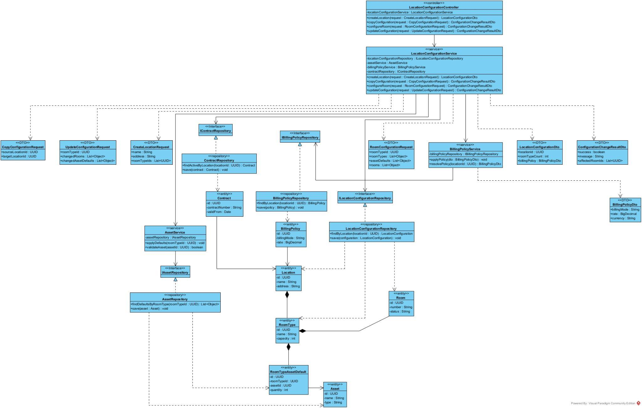

1.2 Create Location and Initial Configuration
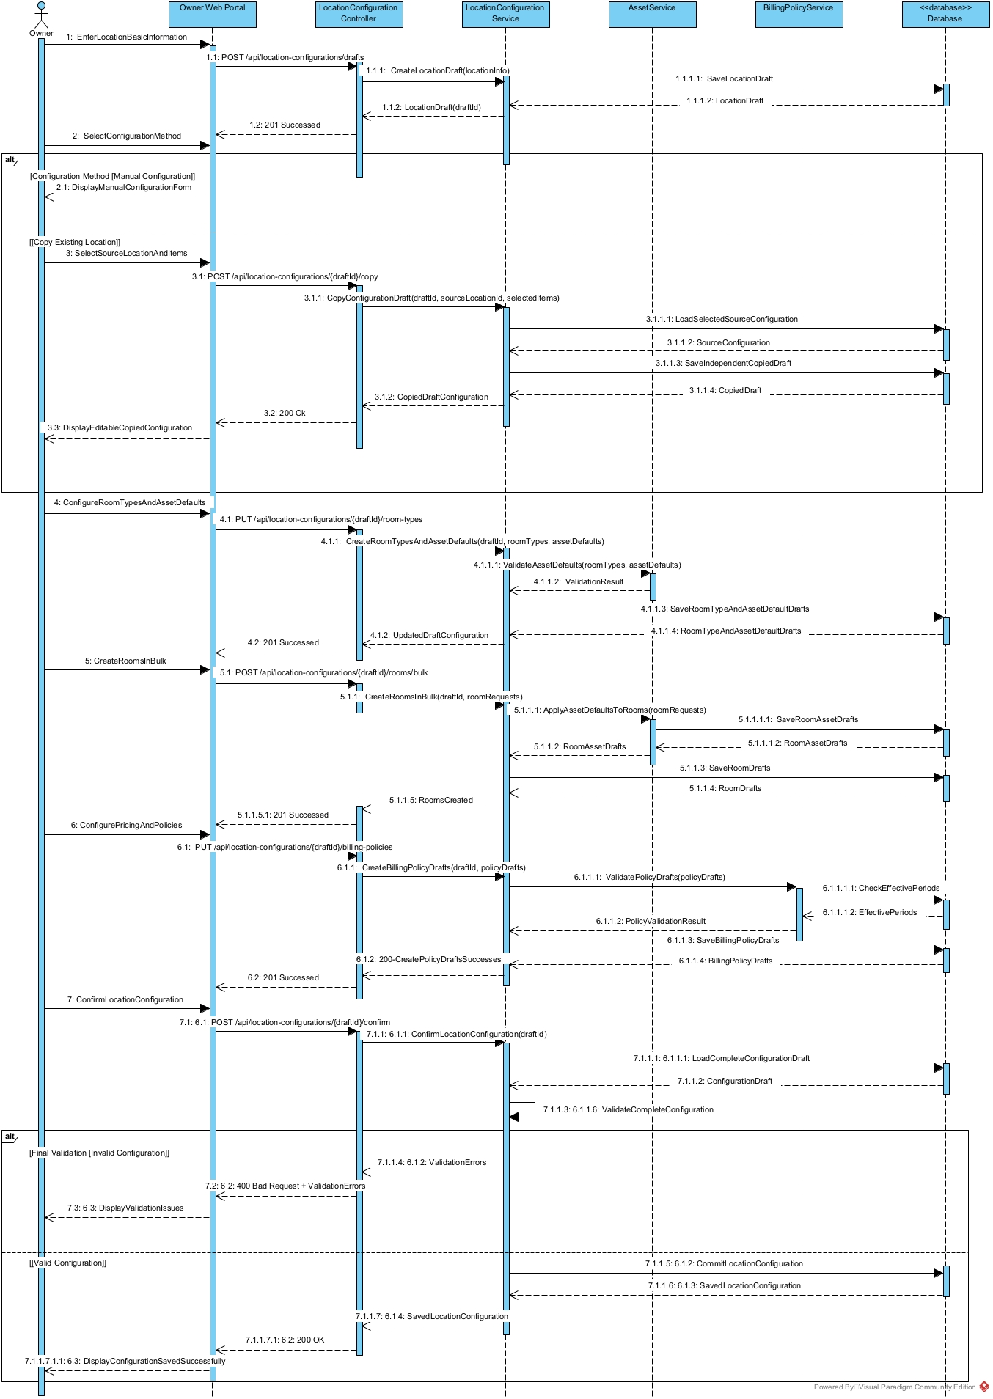

1.3 Update / Remove Location Configuration
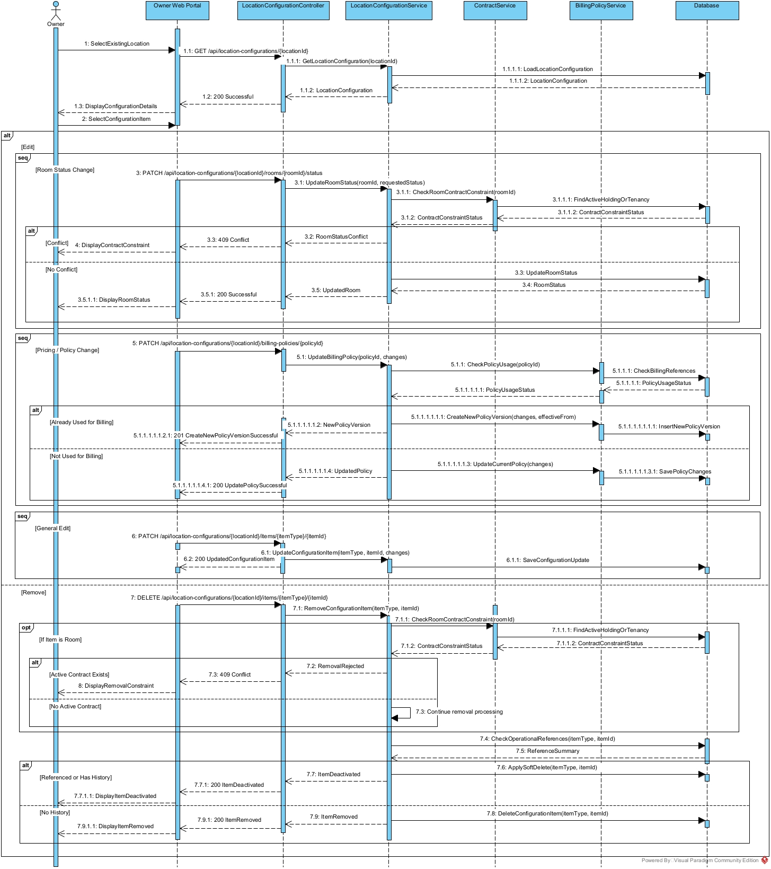

2. Main Tenancy Contract Creation and Activation

2.1 Class Diagram
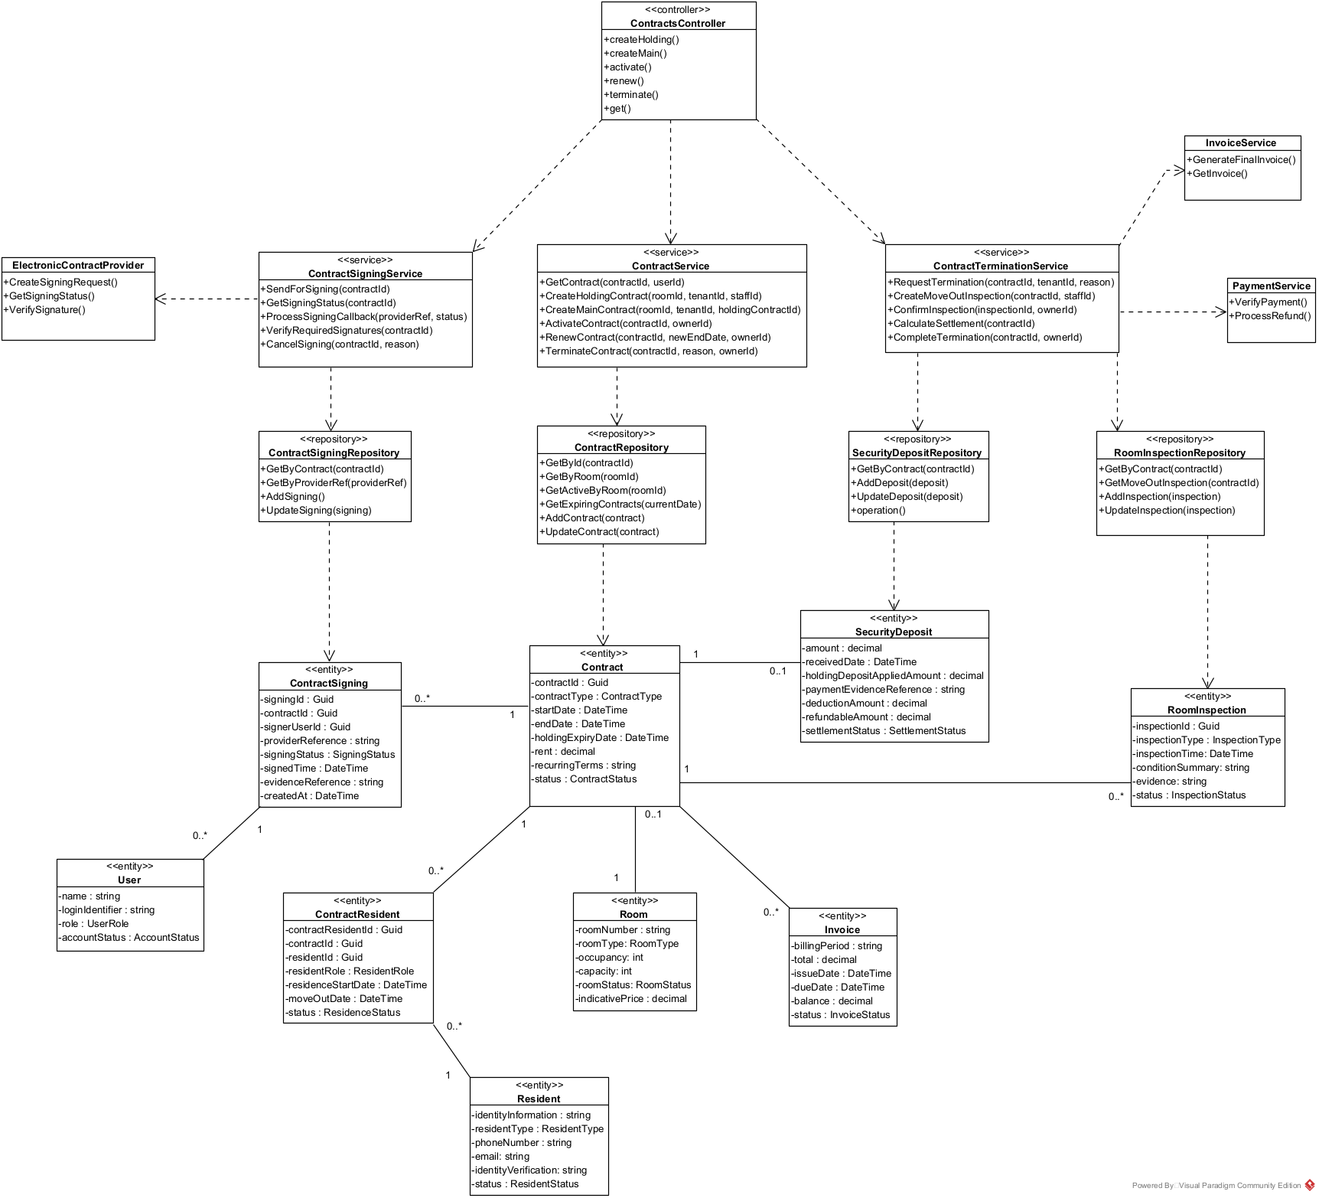

2.2 Main Tenancy Contract Creation and Activation Sequence Diagram

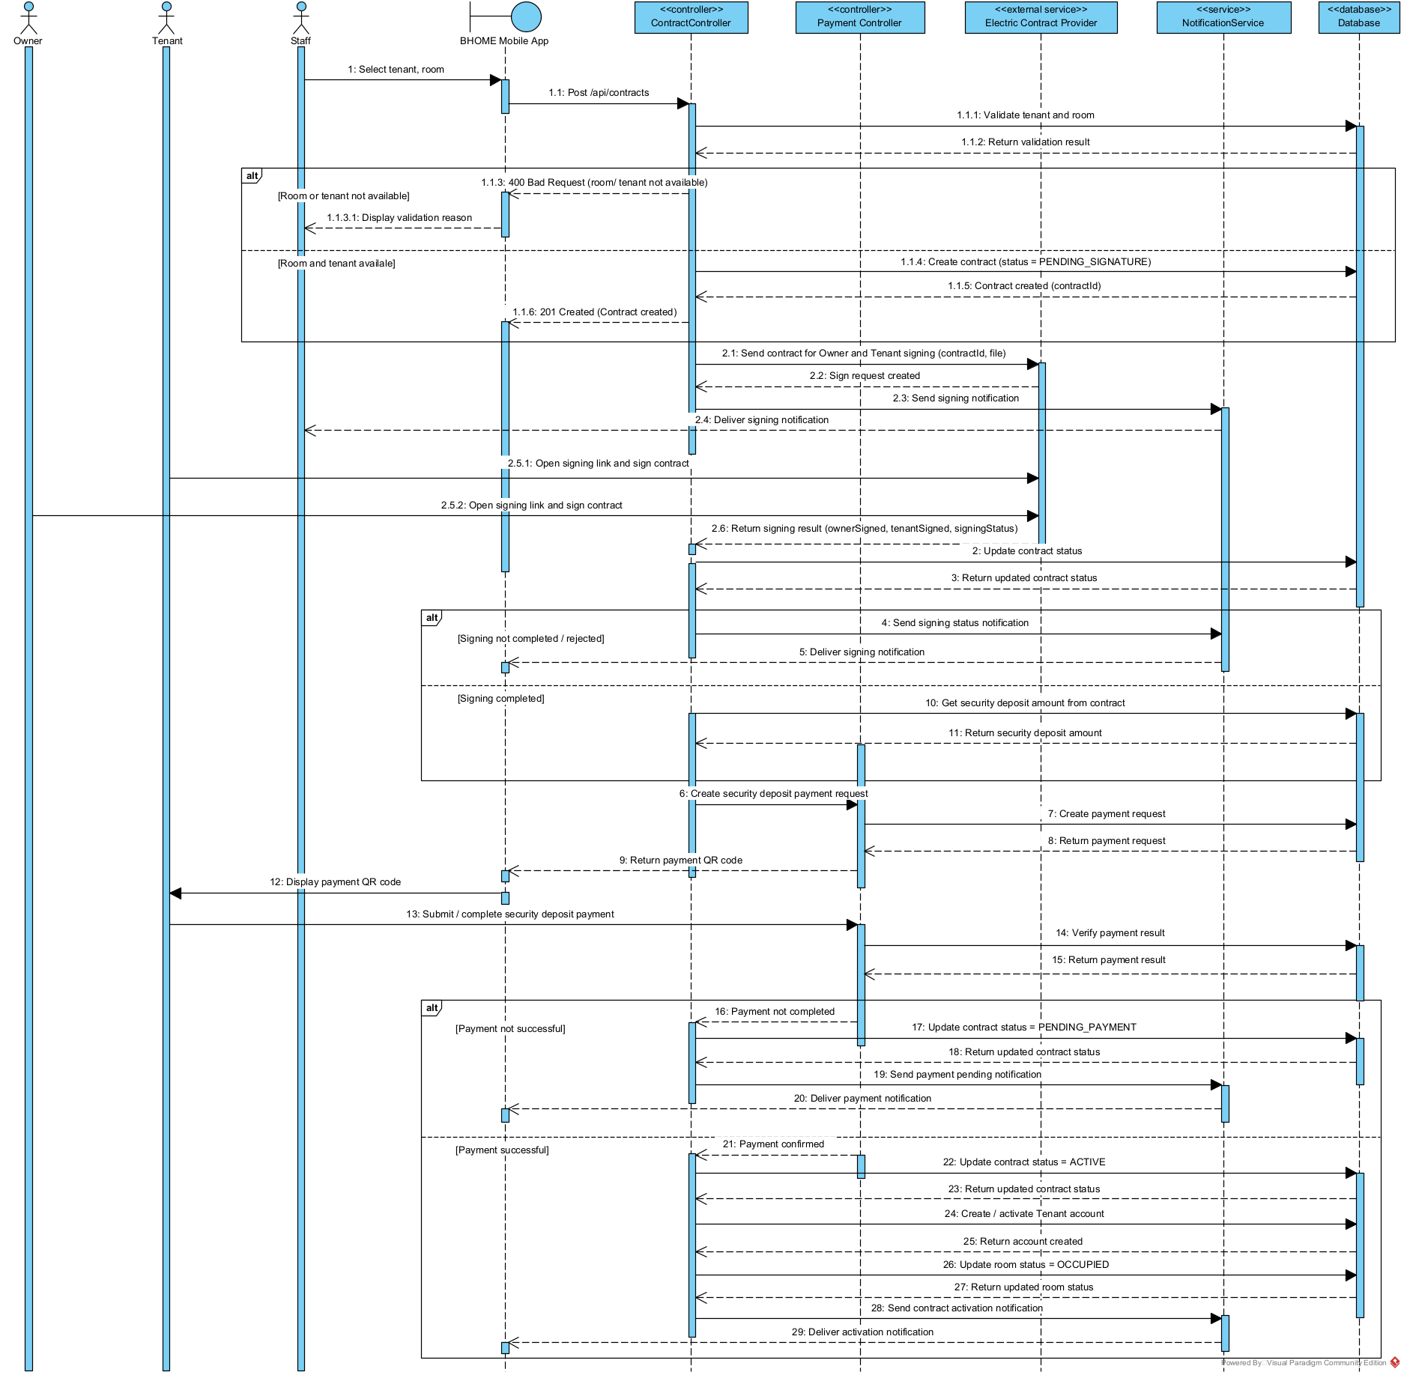

3.Contract Termination and Move-out Settlement

3.1 Contract Termination and Move-out Settlement Sequence Diagram

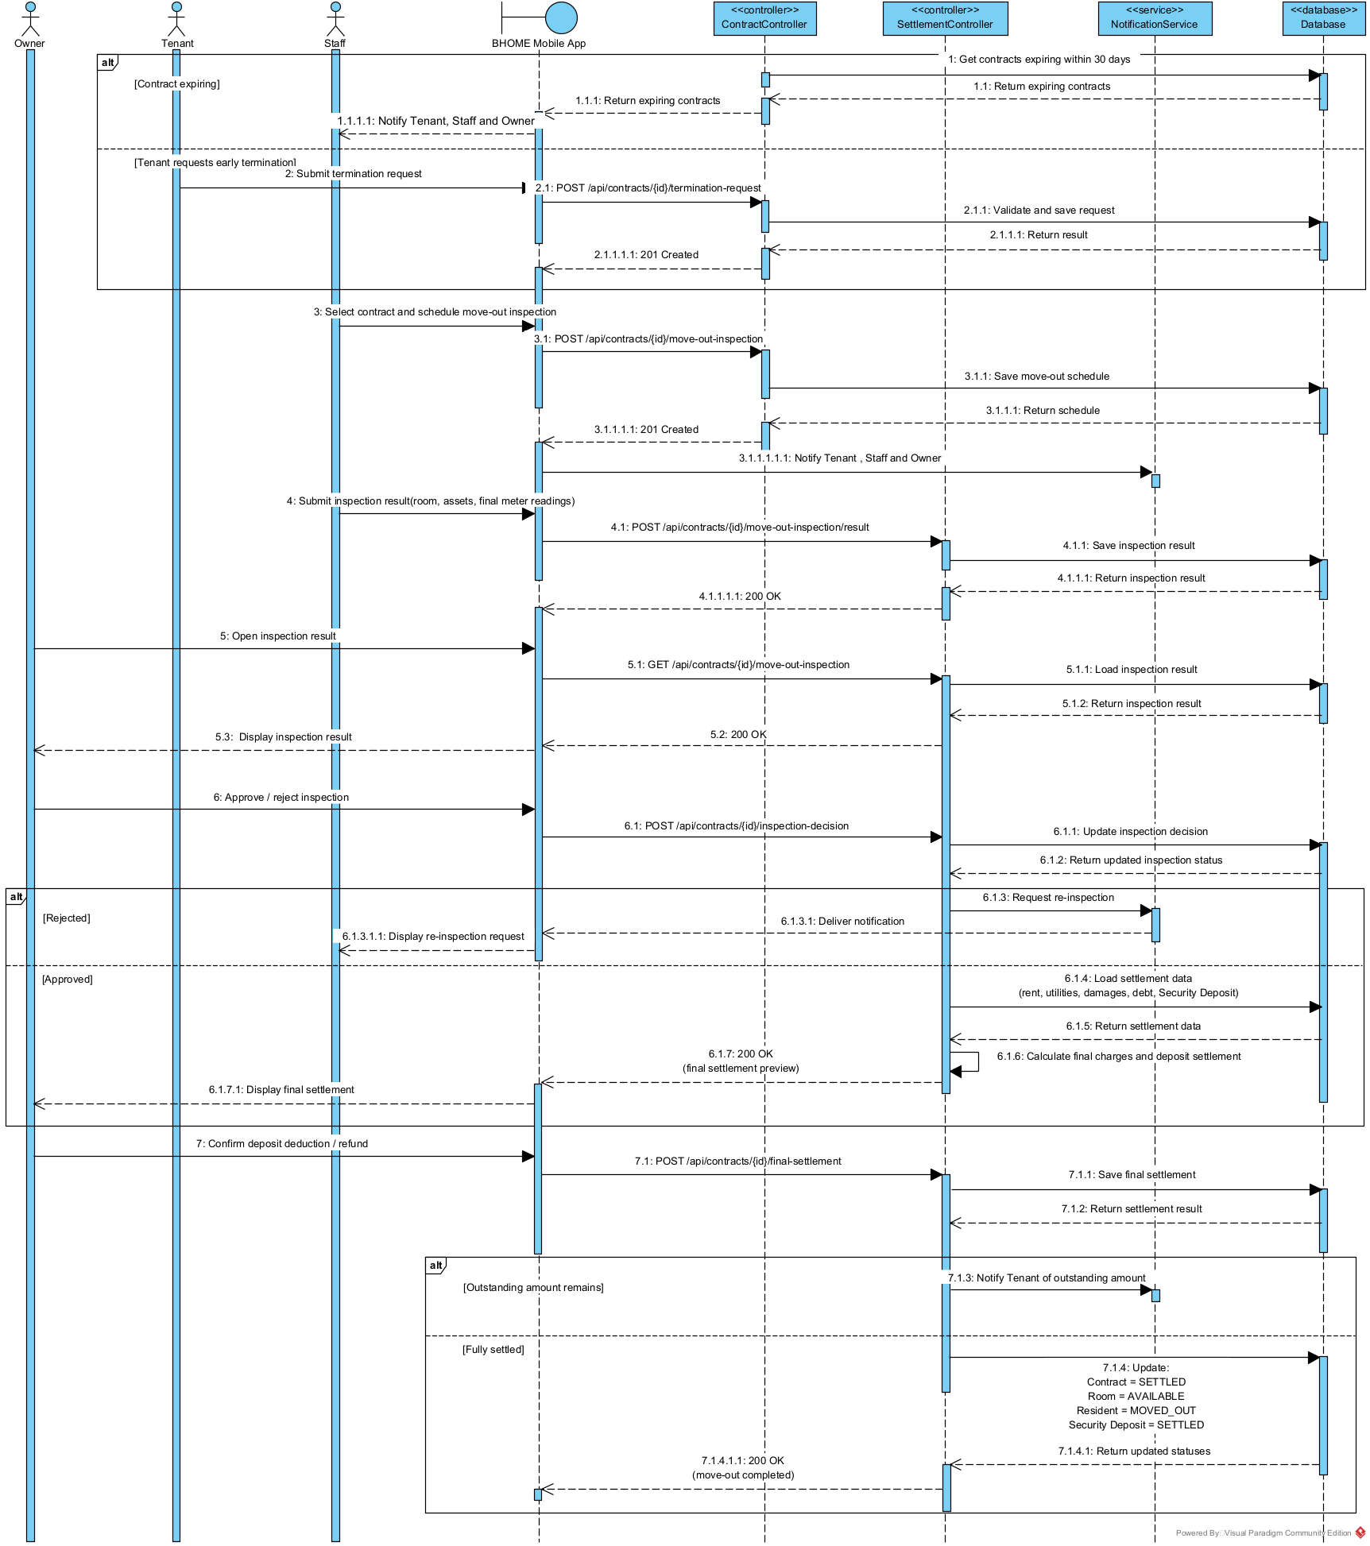

4. Meter Reading, Billing and Payment Management

4.1 Class Diagram
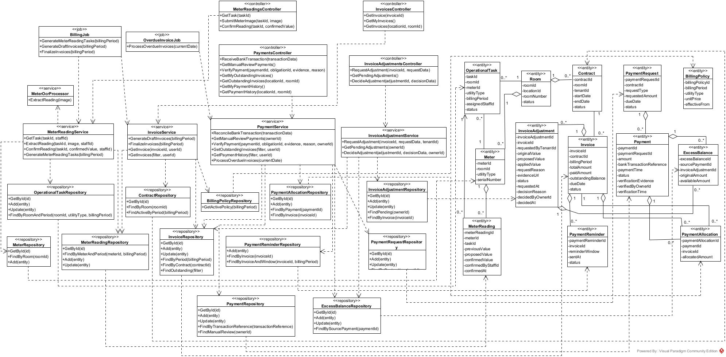

4.2 Meter Reading and Invoice Cycle Sequence Diagram
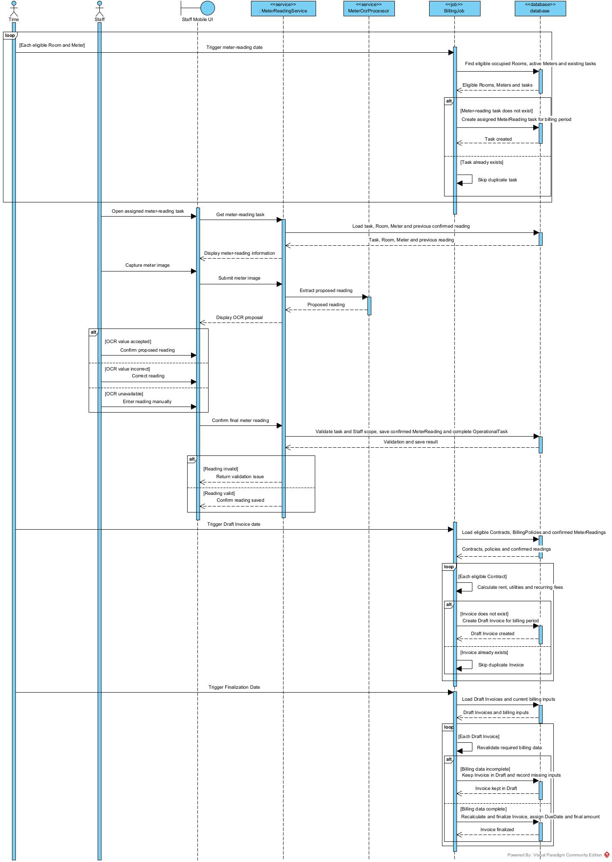

4.3 Bank Payment, Debt and Invoice Adjustment Sequence Diagram
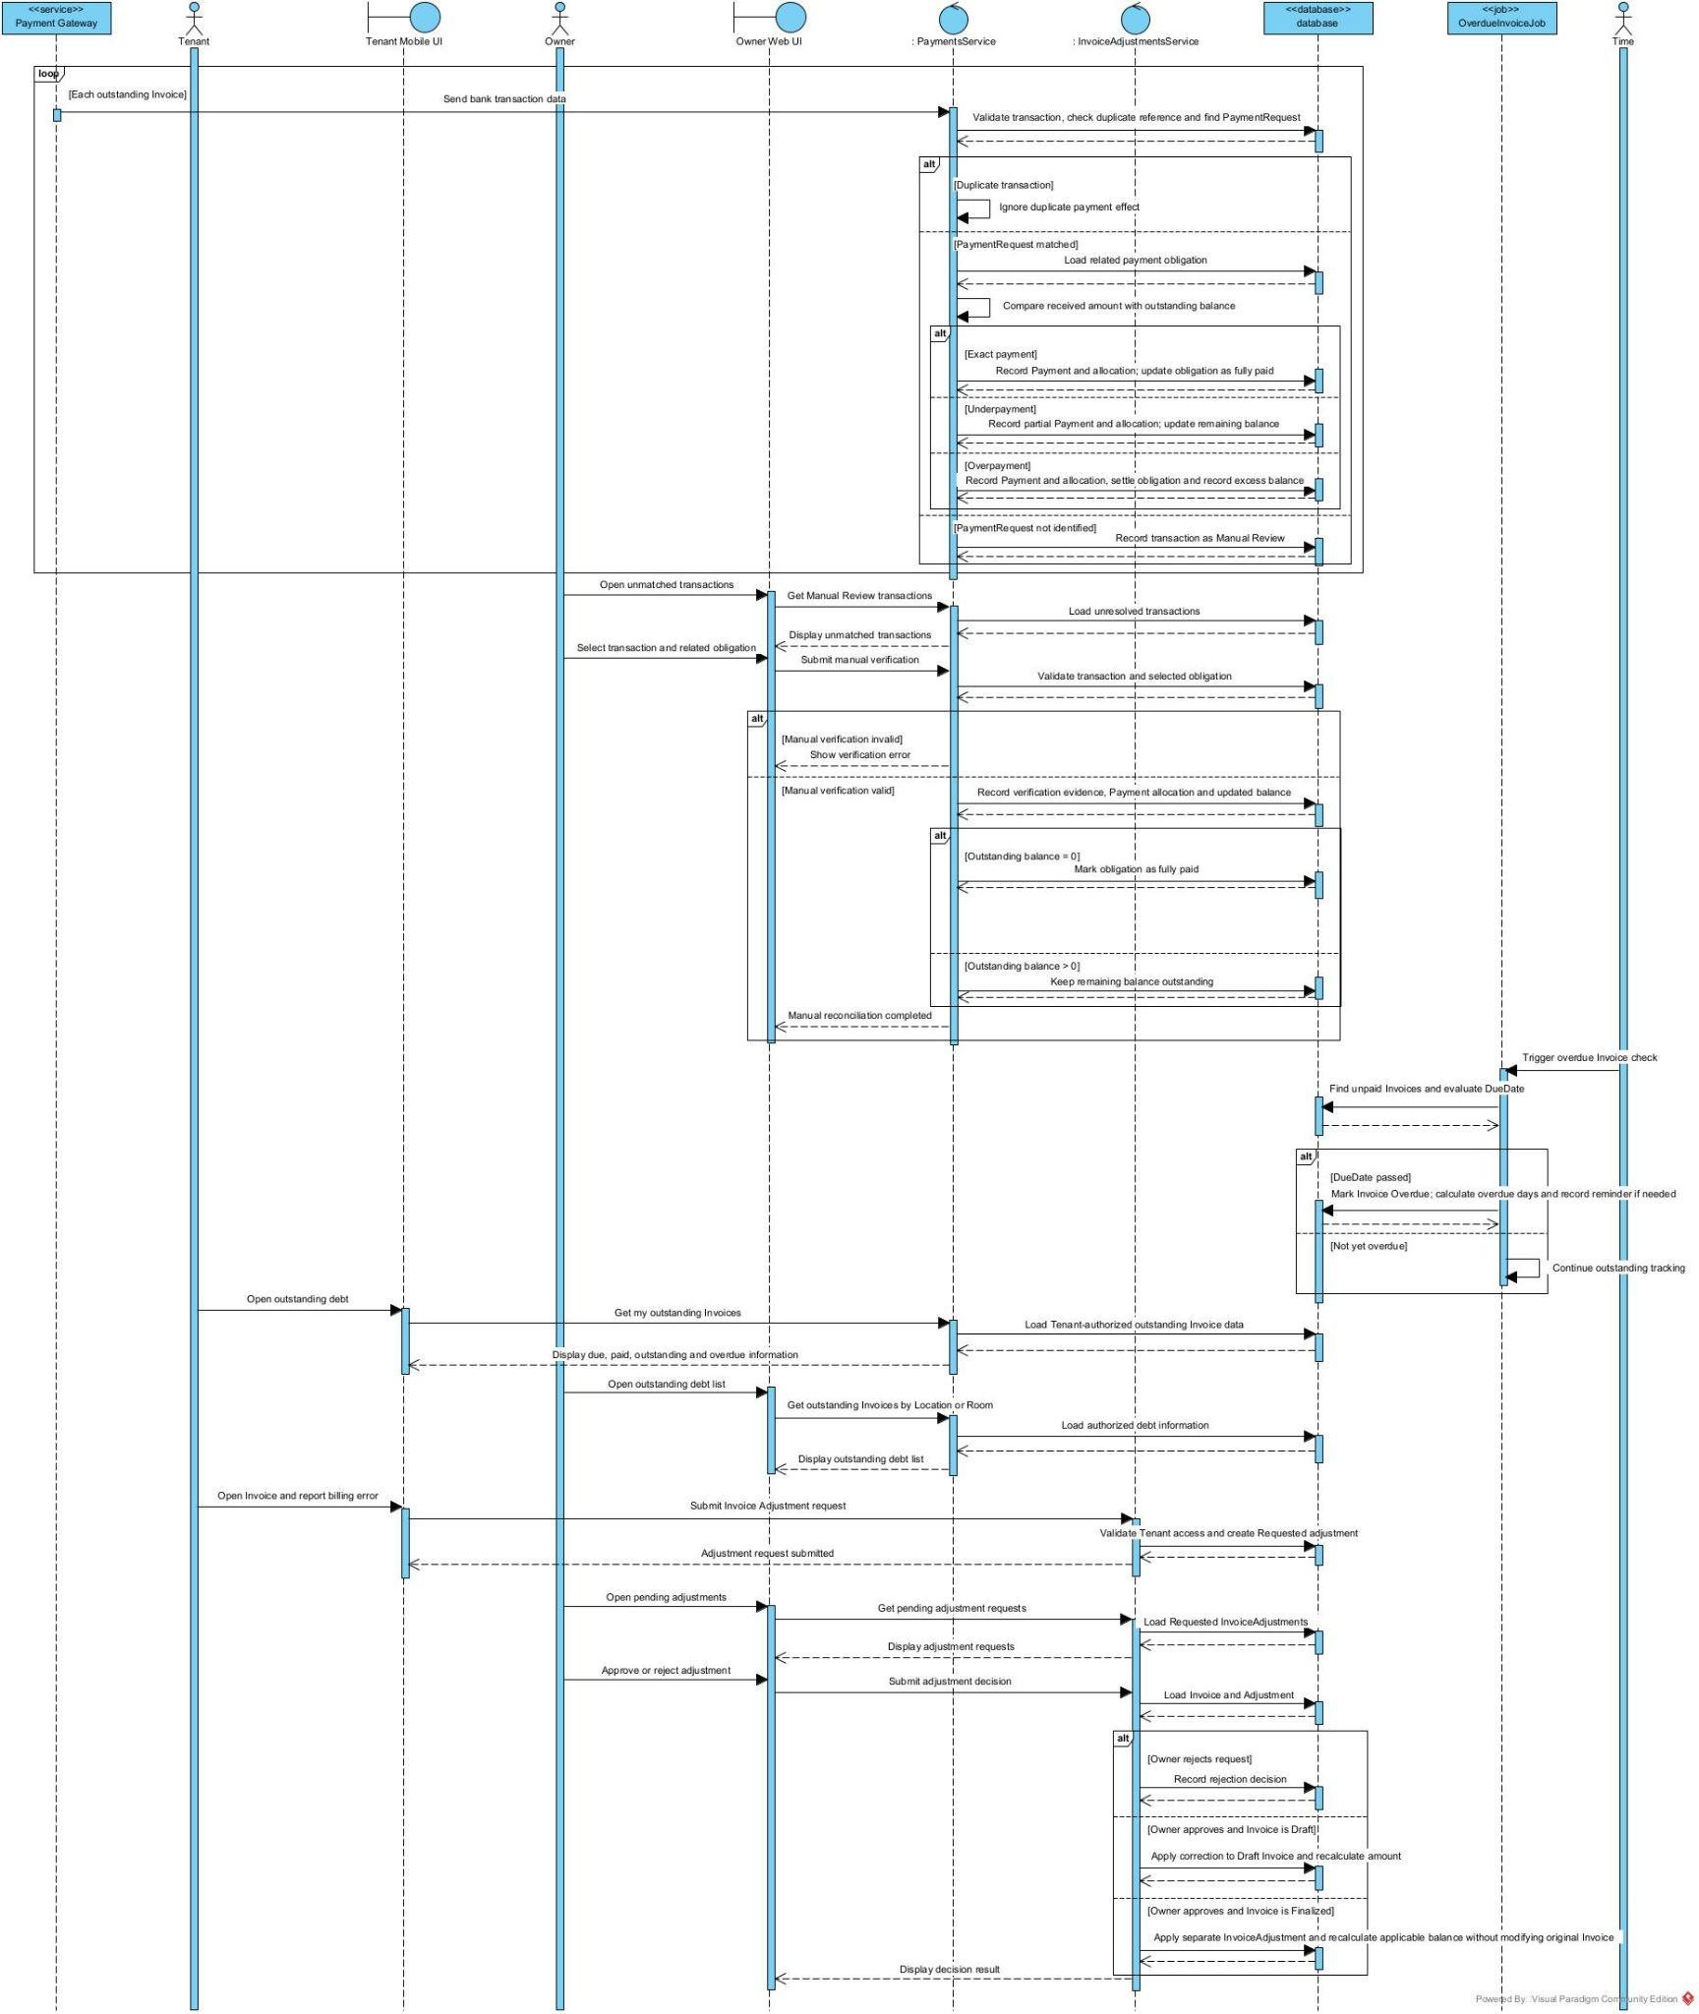

5. Incident and Maintenance Management

5.1 Class Diagram
5.1.1 Incident Reporting and Emergency Response

5.1.2 Maintenance Verification and Cost Recording

5.2 Sequence Diagram
5.2.1 Submit Incident Report

5.2.2 Acknowledge and Record Emergency Action

5.2.3 Verify Work Order and Resolve Incident

III. Design for Non-Functional Requirements

1. Security Design

1.1 Authentication Flow
BHOME uses ASP.NET Core Identity and JWT-based authentication. Owner, Staff and Tenant must sign in before accessing protected functions. After successful authentication, the API issues a JWT access token containing the user identity and role. The token is validated by ASP.NET Core authentication middleware on every protected API request.
Public Website endpoints that expose only Owner-approved public information do not require authentication.
a. Token Design

Aspect | Design Decision
Token format | JWT signed by the BHOME server (HS256); signing key of at least 256 bits loaded from an environment variable
Access token expiry | 30 minutes; configurable per environment
Refresh token expiry | 7 days; rotated on every refresh
Main claims | sub (User ID), role (Owner, Staff or Tenant), sstamp (security stamp), jti
Location scope | Not placed in the token; Staff Location assignments are checked server-side on each request (section 1.2)
Token validation | Signature, issuer, audience, expiry (clock skew 30 s) and security stamp
Server-side storage | Refresh token stored as SHA-256 hash only, per device
Mobile App storage | Refresh token in OS secure storage (Android Keystore / iOS Keychain); access token in memory only
Owner Web Portal storage | Access token in memory; refresh token in an HttpOnly, Secure, SameSite=Strict cookie limited to /api/v1/auth
Logout | Refresh token is revoked; expired access tokens are rejected

b. CORS Configuration
Only trusted BHOME web applications may call the API from browsers. Allowed origins are configured separately for each environment.
Environment | Allowed Origins | Allowed Methods | Allow Credentials | Max Age
Development | Configured localhost origins | GET, POST, PUT, PATCH, DELETE, OPTIONS | Allowed when required | Development
Staging | BHOME staging domains only | GET, POST, PUT, PATCH, DELETE, OPTIONS | Allowed | Staging
Production | BHOME production domains only | GET, POST, PUT, PATCH, DELETE, OPTIONS | Allowed | Production

1.2 Authorization & RBAC Implementation
BHOME uses fixed Role-Based Access Control with Owner, Staff and Tenant roles. Guest is a public, non-RBAC user.
Aspect | Decision
RBAC implementation | ASP.NET Core [Authorize], role policies and service-layer authorization
Owner | Chain-wide access to management, Contract, finance and operational decisions
Staff | Access only to permitted functions and assigned Locations
Tenant | Access only to their own Room, Contract, Invoice, Payment and request data
Guest | [AllowAnonymous] only for approved Public Website information
Role hierarchy | No role inheritance; each role has explicit permissions
Audit | Important Contract, financial, authorization and maintenance actions store actor and timestamp

1.3 Data Protection
Data Category | At Rest | In Transit | Notes
Passwords | Hashed by ASP.NET Core Identity | HTTPS/TLS | Plaintext passwords are never stored or logged
Tenant identity data | PostgreSQL with role-based access | HTTPS/TLS | Only required fields are returned to each role
CCCD images | Temporary processing only | HTTPS/TLS | Deleted after OCR processing; confirmed fields are retained
Contracts / evidence images | Private MinIO/S3 storage | HTTPS/TLS | Accessed only through authorized API requests
Payment information | PostgreSQL with audit history | HTTPS/TLS | Duplicate reconciliation events must not create duplicate payments
API keys / secrets | Environment variables or secret configuration | HTTPS/TLS | Never committed to source code or written to logs
Notification data | Stored only as required | HTTPS/TLS | Sensitive identity and unnecessary financial data are excluded
Database backups | Encrypted backup files in separate storage | HTTPS/TLS | Access limited to the deployment account

2. Performance & Scalability Design
BHOME is designed for the expected MVP scale while keeping the architecture simple. Normal API requests should complete within 2 seconds for at least 95% of requests, the Owner dashboard should load its initial summary within 5 seconds, and the system should support at least 100 concurrent sessions in the evaluation environment.

2.1 Caching Strategy
BHOME uses lightweight application caching for frequently read data. Financial and Contract state-changing operations are not served from stale cache.
What is Cached | Cache Key | TTL | Invalidation Trigger | NFR
Published Location / Room information | public:location:{locationId}, public:room:{roomId} | 5 min | Owner updates, publishes or unpublishes public information; Room becomes vacant or occupied | NFR-PER-01, NFR-PER-03
Owner dashboard summary | dashboard:owner:{ownerId}:{period} | 30 s | Invoice issued or adjusted, Payment confirmed, Expense recorded, Contract activated or ended | NFR-PER-02
Rental rate / fee configuration | pricing:location:{locationId} | 5 min | Owner updates rental rates, fees or billing policy | NFR-PER-01
Location and Room lookup lists | lookup:locations:{ownerId}, lookup:rooms:{locationId} | 10 min | Location or Room created, updated or archived | NFR-PER-01
Staff Location assignments | staffscope:{staffId} | 5 min | Assignment added or removed (invalidated immediately so access changes apply at once) | NFR-SEC-02, NFR-PER-01
…

2.2 Database Query Optimization
PostgreSQL queries are accessed through Entity Framework Core and optimized as follows:

Area | Design
Indexing | Add indexes to frequently searched and filtered columns such as Location, Room status, Contract status, Invoice status/due date and task deadline
Unique data | Use unique constraints for transaction references and other idempotency keys
List APIs | Use server-side filtering, sorting and pagination
Read-only queries | Use EF Core AsNoTracking() where entity updates are not required
Data loading | Load only required fields and avoid unnecessary related entities
Dashboard | Use database aggregation instead of loading all records into application memory
Transactions | Financial and Contract updates use database transactions where multiple related records must remain consistent

2.3 Background Processing
Scheduled operations such as Invoice generation, payment retries, reminders and recurring tasks run through Background Jobs instead of blocking interactive API requests.
Each retryable job uses an idempotency check so that retries cannot create duplicate Invoices, Payments, Contracts or Notifications.
Internal OCR processing should return either an OCR proposal or a manual-entry fallback state within 10 seconds under the evaluation workload.

3. Reliability & Recoverability Design

3.1 Integration Failure Handling
External service failures must not corrupt existing BHOME business data.

Component | Failure Handling
Internal OCR | Allow manual entry when OCR fails
Payment Provider | Retry reconciliation; Owner can manually verify unmatched transactions
Notification Service | Keep in-app notification and retry external delivery
Electronic Contract Provider | Keep Contract in Pending Signing until signing succeeds
MinIO / S3 Object Storage | A failed upload aborts the business transaction, so no record points to a missing file
Background Jobs | Log failure and retry or move the item to an explicit review state

3.2 Data Consistency & Recovery

Aspect | Design Decision
Financial consistency | Invoice, Payment, Debt, Deposit and Adjustment updates use controlled transactions
Idempotency | Duplicate external events and job retries do not create duplicate business effects
Failure logging | Failed jobs and external calls are recorded for review
Database backup | Daily PostgreSQL backup
Recovery Point Objective | RPO: 24 hours
Recovery Time Objective | RTO: 8 hours
File upload | Incident evidence supports up to 5 images, maximum 5 MB per image

4. Privacy & Test Data Design

Area | Design Decision
Test data | Use synthetic, mock or anonymized Tenant data for development and testing
CCCD OCR | CCCD images are temporary inputs and are deleted after processing
Stored identity data | Store only Staff-confirmed identity fields and required verification metadata
API responses | Return only information required by the current role and workflow
Logging | Sensitive identity, credentials and financial data are excluded from unrestricted logs
Notifications | Do not include unnecessary sensitive identity or financial information
Public Website | Expose only Owner-approved non-sensitive Location and Room information
Former Tenants | After a Contract ends, the Tenant keeps read-only access to their own Contract, Invoices and payment history; Staff loses access to their identity data

5. Usability Design
BHOME follows a mobile-first design for Owner monitoring, Staff operations and Tenant self-service.

Aspect | Design Decision
UI language | Vietnamese for MVP
Currency | VND, thousands separator, no decimals
Time zone | Asia/Ho_Chi_Minh (UTC+7); stored in UTC, displayed in local time
Date format | dd/MM/yyyy
OCR confirmation | OCR-proposed values are visually distinguished from confirmed values until Staff confirms them
Error messages | Clearly explain the required corrective action without exposing sensitive data (section 3.3)
Manual fallback | Manual Meter/CCCD entry and manual payment verification remain available when automated processing fails (NFR-USA-02)
Emergency reporting | Emergency severity is selectable in one step on the report screen; the app shows the life-safety hotline for fire, gas leak or injury
Direct handling | The Owner can record actual cost and verify an incident directly on mobile without creating a Work Order for Staff
Destructive actions | Contract termination, Invoice adjustment and Work Order rejection require a confirmation step with a reason
Terminology | Owner, Staff, Tenant and Guest terminology is used consistently throughout the system

